15/11/18
THM 121 Business Mathematics
Midterm Exam Answer Sheet
Note to the students:
- Calculations to reach your answers shall be thoroughly shown. Otherwise, questions will NOT be graded.
- You can use a calculator throughout the exam.
- Factor and simplify the given expression as much as possible: (2 Points)
3χ³ – χ²y + 6χ²y - 2χy² + 3 χy² – y³
3χ³ – χ²y + 6χ²y - 2χy² + 3 χy² – y³ = χ² (3χ – y) + 2χy (3χ – y) + y² (3χ – y) = (3χ – y) (χ² + 2χy + y²) = (3χ – y) (χ + y)².
- Simplify the given rational expression: (2 Points)
(χ² - 9χ + 14) / (χ² + 2χ – 8)
(χ² - 9χ + 14) / (χ² + 2χ – 8) = (χ – 2) (χ – 7) / (χ – 2) (χ + 4) = (χ – 7) / (χ + 4) [Assuming χ ≠ 2 and – 4].
- Factor the given polynomial using integer coefficients: (2 Points)
2χ³ + χ² - 3χ
2χ³ + χ² - 3χ = χ (2χ² + χ – 3) = χ (χ – 1) (2χ + 3).
- Solve the following quadratic equation by completing the square: (2 Points)
χ² + 6χ + 2 = 0
χ² + 6χ + 2 = 0 ↔ χ² + 6χ = - 2 ↔ χ2 + 6χ + (6 / (2*1))² = - 2 + (6 / (2*1))² ↔ χ2 + 6χ + (3)² = - 2 + (3 )² ↔ χ2 + 6χ + 9 = 7 ↔ (χ + 3)² = 7 ↔ χ + 3 = OR χ + 3 = - ↔ χ = -3 + OR χ = -3 - .
- Use the quadratic formula to solve the following equation: (2 Points)
3χ² - 6χ - 23 = 0
∆ = (-6)² – 4 (3) (-23) = 36 + 276= 312 = 4 * 78. Therefore, there are 2 solutions of this equation:
Either χ = (6 + 2 √78) / 6 or χ = (6 – 2 √78) / 6 ↔ either χ = (3 + √78) / 3 or χ = (3 - √78) /3.
- Solve the given system of equations: (3 Points)
-3χ + y = - 9 AND 5 χ + 4y = 32
(i) -3χ + y = - 9 (ii) 5 χ + 4y = 32; From (i), we get y = -9 + 3χ If we substitute the value of y in equation (ii), we get: 5 χ + 4 (-9 + 3χ) = 32 ↔ 5 χ -36 + 12χ = 32 ↔ 17 χ = 68 ↔ χ = 4. Substituting χ with a value of 4 either in (i) or (ii), we get that y = 3.
- Evaluate the given sum: (2 Points)

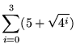
(5 + √1) + (5 + √4) + (5 + √16) + (5 + √64) = (5 +1) + (5 + 2) + (5 + 4) + (5 + 8) = 6 + 7 + 9 + 13 = 35.
- Express the given sum in term of summation notation: (2 Points)
1 + (1/2) + (1/3) + (1/4) + ………
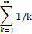
- Find the composite function ƒ(g(u)) such that: (2 Points)
ƒ(u)= -4u + 9 AND g(u) = 2u – 7
ƒ(g(u)) = ƒ(2u - 7) = -4 (2u – 7) + 9 = -8u + 28 + 9 = -8u + 37.
- Suppose the total cost of manufacturing q units of a certain product is C (q) thousand dollars, where:
C (q) = 0.02q² + 0.80 q + 4
- Find the total cost and average cost of producing 12 units. (2 Points)
- Total cost of 12 units = C (12) = 0.02 (12)² + 0.80 (12) + 4 = 2.88 + 9.60 + 4 = 16.48.
Therefore, the total cost of producing 12 units is $ 16,480.
- Average cost per unit when 12 units are manufactured is: C (12) / 12 = 16,480 / 12 = $ 1,373.33.
(b) Find the cost of producing the 12th unit. (1 Point)
The cost of producing the 12th unit is C (12) – C (11) = 0.02 (12²-11²) + 0.80 (12 – 11) = 0.02 * 23 + 0.80 = 0.46 + 0.80 = 1.26.
Therefore, the cost of producing the 12th unit is $ 1,260.
- Suppose that the number of worker-hours required to distribute new telephone books to χ % of the households in a certain rural community is given by the function:
W (χ) = (700χ) / (400 – χ)
- What is the domain of the function W? (1 Point)
The domain of W function are all real numbers except when χ = 400.
- For what values of χ does W (χ) have a practical interpretation in this context? (1 Point)
Typically, the domain would be restricted to the first quadrant. That is, x ≥ 0. However, since x is a
percentage, the restriction should be 0 ≤ x ≤ 100.
- How many worker-hours were required to distribute new telephone books to the first 50 % of the households? (1 Point)
When χ = 50, W (50) = 700 (50) / (400 – 50) = 100 Worker-hours.
- How many worker-hours were required to distribute new telephone books to the entire community? (1 Point)
When χ = 100, W (100) = 700 (100) / (400 – 100) = 233.33 Worker-hours.
- What percentage of the households in the community received new telephone books by the time 200 worker-hours had been expanded? (1 Points)
Here, we shall find x when W(x) = 200. This means (700χ) / (400 – χ) = 200 ↔ 700χ = 200 (400 – χ)
↔ 7χ = 800 – 2χ ↔ 9χ = 800 ↔ χ = 88.89. Therefore, after 200 worker-hours, 88.89 % of the
households would have received a new telephone book.
- Lead emissions are a major source of air pollution. Using data gathered by the U.S. Environmental Protection Agency in the 1990s, it can be shown that the formula:
N (t) = -37 t² + 305 t + 4023
estimates the total amount of lead emission N (in thousands of tons) occurring in the United States t years after the base year 1990.
- Sketch the graph of the pollution function N (t). (3 Points)

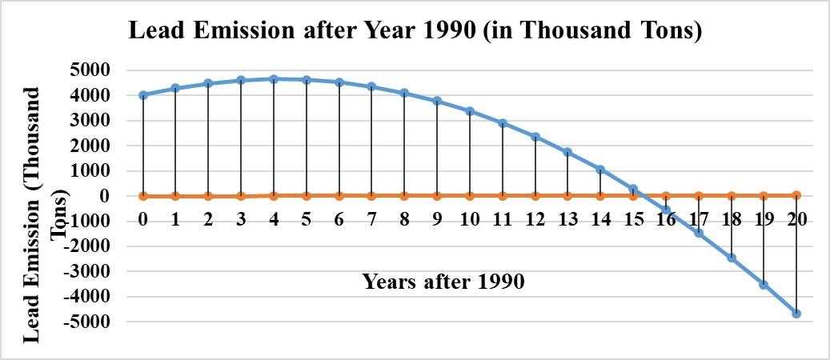
- Approximately, how much lead emission did the formula predict for the year 1998? (The actual amount was about 4,000 thousand tons). (1 Point)
Since the year 1998 is represented by t = 8, the amount predicted was:
N (8) = -37 (8)² + 305 (8) + 4023 = - 2368 + 2440 + 4023 = 4,095 thousand Tons.
- Based on this formula, when during the decade 1990 – 2000 would you expect the maximum lead emission to have occurred? (1 Point)
Based on the formula, the maximum lead emission would occur at the vertex, or when t (i.e. Years after 1990) = - 305 / 2(-37) = 305 / 74 = 4.12 years. This would occur during the month of February, 1994.
- Can this formula be used to accurately predict the current level of lead emission? Explain. (1 Point)
No; from the graph, N (t) < 0 occurs when t ≈ 16, or during the year 2006. Therefore, since we are in year 2018, this formula will yield a negative N (t) which is not appropriate.
N.B. Round your answers to the nearest cent for questions 10, 11 & 12.
GOOD LUCK!

